Install On Premise Data gateway Stanadard Mode and signin with rogers/amdocs username/pwd

<https://powerbi.microsoft.com/en-us/gateway/>

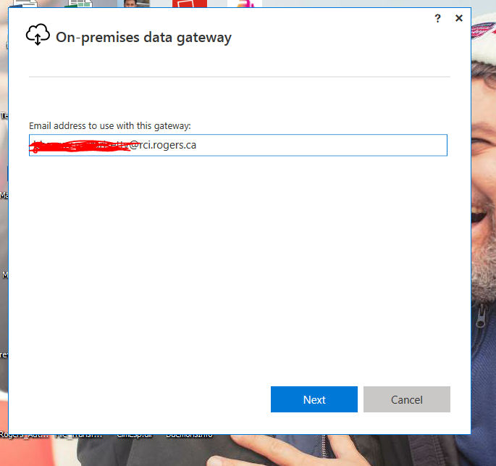

Click on next and give a Gateway Name (without spaces) and unique reset key (‘preferably same as gateway name’)

Once everything is done you will see this screen.

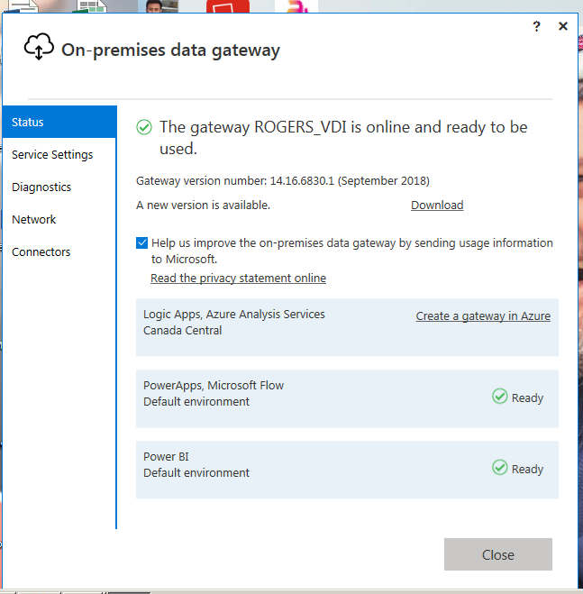

ROGERS_VDI is name of my gateway in above screen, you will see same screen with your gateway name.

Click on close.

Go to your desktop and double click on .pbix files

Click on Publish and click ok.

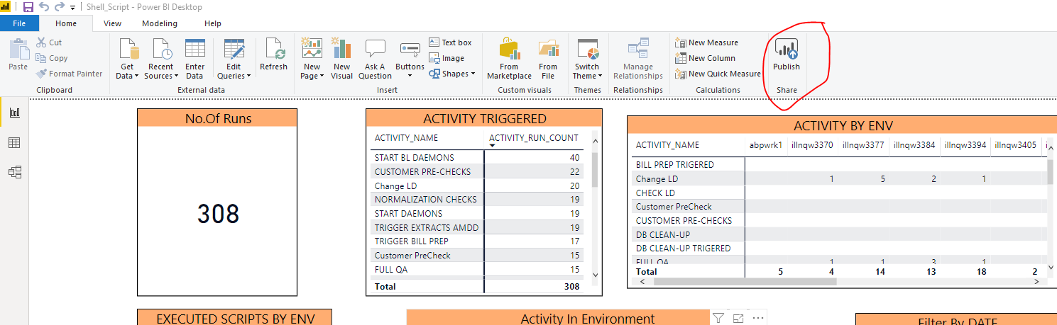

Now go to <https://powerbi.microsoft.com/en-us/> and signin

After sign in now go to manage gateways

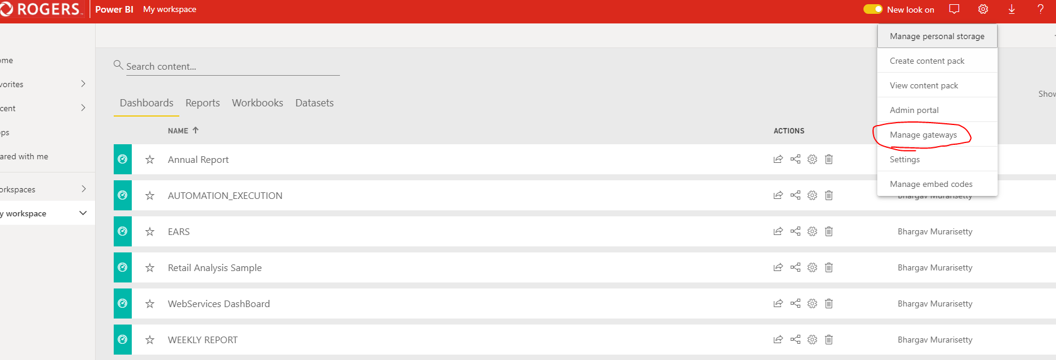

Click on your gateway and select all the check boxes

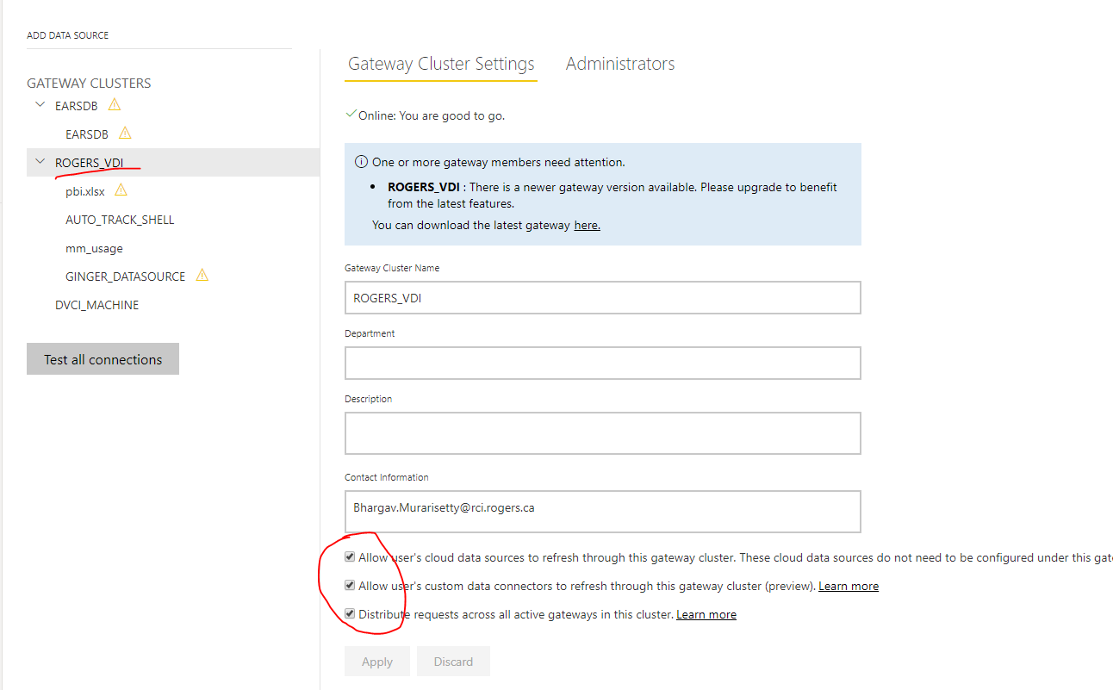

Save the changes and go back to home screen

1. Click on Reports tab
2. Click on view related icon
3. Click on refresh dataset icon

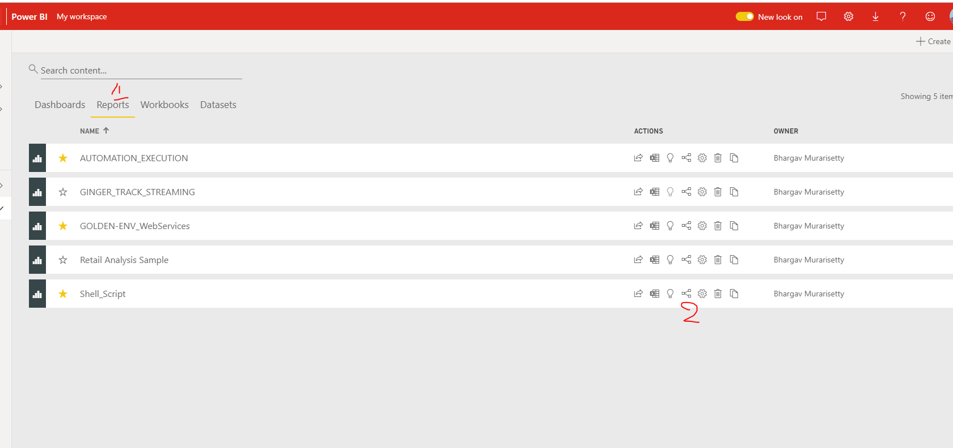

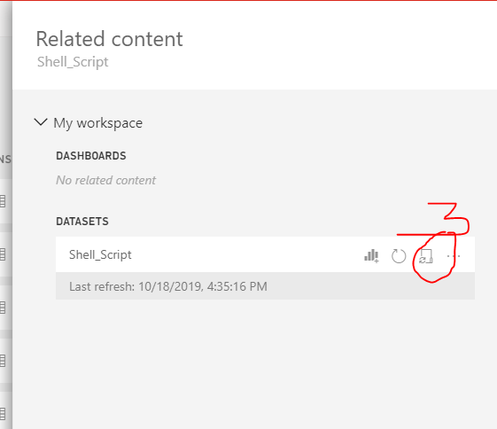

Click on gateway connection and make sure Gateway is UP and Running and DB details are selected below it.

